**Session 2 Try if yourself**

1.C is case sensitive. (True / False) **True**

2.The number 10 is a **integer**_______________.

3.The first character(*ký tự*) of the identifier(*định danh*) can be a number. (True / False) true

4.Using the type(*kiểu*) float_ saves memory(*bộ nhớ*) as it takes only half the space(*1 nửa không gian)* as a double would.

5.The _______ data type is used to indicate(*biểu thị)* the C compiler*(trình biên dịch*) that no value (*giá trị*)is being returned(trả về).

6 Bitwise and logical are the two classes of arithmetic operators.

A. Bitwise & and | B. Unary and Binary

C. Logical AND bitwise D. None of the above

7.The unary arithmetic operators are ++and -- .

A. ++ and – – B. % and ^

C. ^ and $ D. None of the above

Ex2:

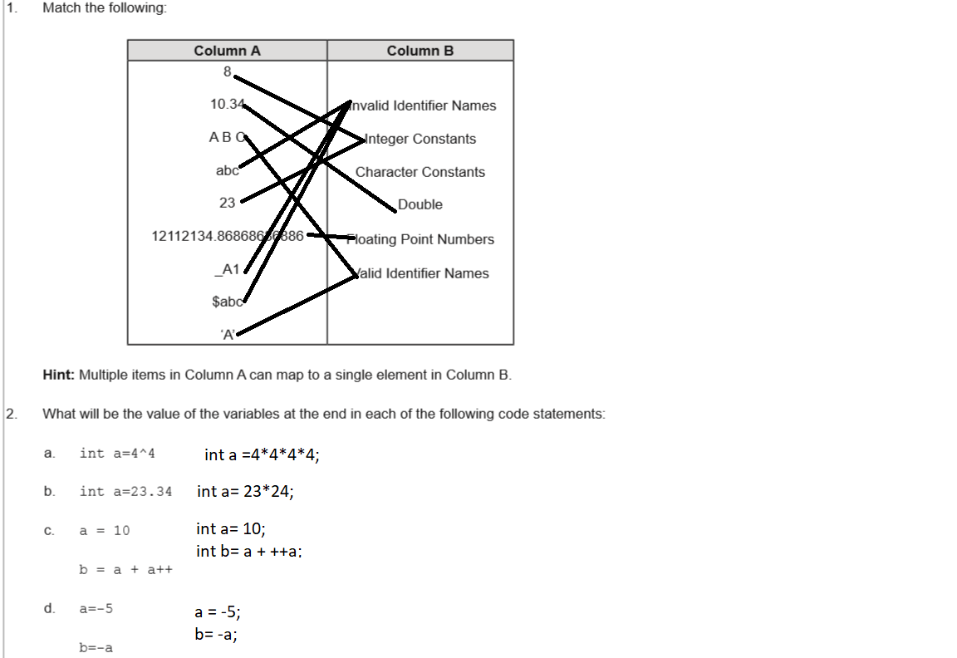

**Sesson 3: try if yourself**